**A.M. Klein (1909-1972)**

A.M. (Abraham Moses) Klein, one of Canada's leading Modernists, is best known for his poetry depicting Jewish and French Canadian experiences in the first half of the twentieth century. As a central figure in Jewish-Canadian culture, many of his poems represent Jewish identity and heritage, themes he sought to reconcile with the Modernist desire to break from history. He also wrote short stories, novels, and literary essays, including several on James Joyce's *Ulysses.*  
  
Klein was born on February 14, 1909 in Ratno, Ukraine, and shortly thereafter his family immigrated to Montreal's working-class Jewish district, the setting that inspired much of Klein's poetry. From 1926 to 1930, Klein studied at McGill University, where he was influenced by an early Canadian modernist literary circle, the McGill Movement of A.J.M. Smith, F.R. Scott, and Leo Kennedy. Klein co-founded a literary magazine, *McGilliad*, and published early works in literary magazines.

Klein became involved with the Zionist organization Canadian Young Judaea as an educator and writer. After studying law at the Université de Montréal (1930-1933), Klein began his career as a lawyer. He was editor and columnist (1936-55) for the Zionist Organization of Canada's magazine, *The Canadian Zionist,* and *The* *Canadian Jewish Chronicle*. He also worked as a speech writer for Samuel Bronfman, President of the Canadian Jewish Congress.  
  
Klein’s first book of poetry, *Hath Not a Jew* (1940)*,* contains poems from the 1920s and 1930s addressing his Jewish community’s culture and experience of anti-Semitism. In the 1940s, Klein associated with Montreal poets the Previewgroup (F. R. Scott, P.K. Page, Patrick Anderson) and the First Statement group (including Irving Layton) and lectured in poetry at McGill University. In 1944, *The Hitleriad*, a satirical poem about Nazi Germany’s threat to European Jews, and *Poems* werepublished.   
  
Departing from his focus on Jewish culture, in 1946, Klein wrote his first unpublished novel, “Comes the Revolution” (retitled “That Walks Like a Man”), inspired by the Igor Gouzenko affair of Soviet espionage in Canada. Klein's next volume of poetry, *The Rocking Chair and Other Poems* (1948), depicted Quebec's French-Canadian community and won the Governor-General's Medal (1949).  
  
Involved in politics, in 1944, Klein was nominated but withdrew as Co-operative Commonwealth Federation (CCF) candidate in Montreal-Cartier, Quebec. He ran unsuccessfully for the position in 1949.  
  
That year, the Canadian Jewish Congress sponsored Klein's travel to Israel, Europe, and North Africa, and over the next three years, he lectured on the State of Israel throughout Canada and America. He described his early travels in “Notebook of a Journey,” published in *The* *Canadian Jewish Chronicle.* Inspired by visiting Israel and witnessing European and North African refugee camps at the end of World War Two, Klein's only published novel, *The Second Scroll* (1951)*,* recounts a contemporary search for a Messiah to guide the Jews to the Promised Land.  
  
Klein became depressed while writing *The Second Scroll* and attempted suicide in 1954. He soon ceased writing and withdrew from public life, including resigning from law in 1956.   
On August 20, 1972, Klein died in his sleep. Several of his short stories and poems were published posthumously.  
  
**Key Biographies of A.M. Klein**  
Caplan, Usher. *Like One That Dreamed: A Portrait of A.M. Klein*.

Carousel Films. *A.M. Klein: The Poet as Landscape* [motion picture].

Kattan, Naïm. Trans. Edward Baxter. *A.M. Klein: Poet and Prophet.*

Marshall, Tom, ed. *A.M. Klein: Critical Views on Canadian Writers*.

Mayne, Seymour, ed. *The A.M. Klein Symposium*.   
Pollock, Zailig. *A.M. Klein: The Story of the Poet*.

**Annotated Bibliography**

Pollock, Zailig, Usher Caplan, and Linda Rozmovits. *A.M. Klein, An Annotated Bibliography*.

**Chronology of All Works**  
Letters  
*A.M. Klein: The Letters*, edited by Elizabeth Popham and Harold Heft. Toronto: University of Toronto Press. (in progress)

Notebooks  
*Notebooks: Selections from the A.M. Klein Papers*. Ed. by Zailig Pollock and Usher Caplan, with an introd. by Zailig Pollock. Toronto: University of Toronto Press, 1994.   
  
Poetry  
*Hath not a Jew* (1940)   
*Poems* (1944)  
*The Hitleriad* (1944)

*Seven Poems* (1947)  
*The Rocking Chair: and Other Poems* (1948)   
*The Collected Poems of A. M. Klein* (1974)

*A.M. Klein: The Complete Poems* (1990)

*Doctor Dwarf and Other Poems for Children* (1990)  
  
Essays  
*Beyond Sambation: Selected Essays and Editorials, 1928-1955* (1982)   
*Literary Essays and Reviews* (1987)   
  
Novels

*The Second Scroll* (1954)

Short Stories  
*The Short Stories of A.M. Klein* (1983)

Drama

Hershel of Ostropol in Canadian Jewish Chronicle (1939)

Translations

Trans. Moishe Dickstein's From Palestine to Israel (1951)  
Trans. Israel Rabinovich’s Of Jewish Music, Ancient and Modern (1952)

Adaptations

Conscience (from Pedro Bloch’s play The Hands of Euridice), Trans. Claude Vincent (1952)

**Paratextual Material**

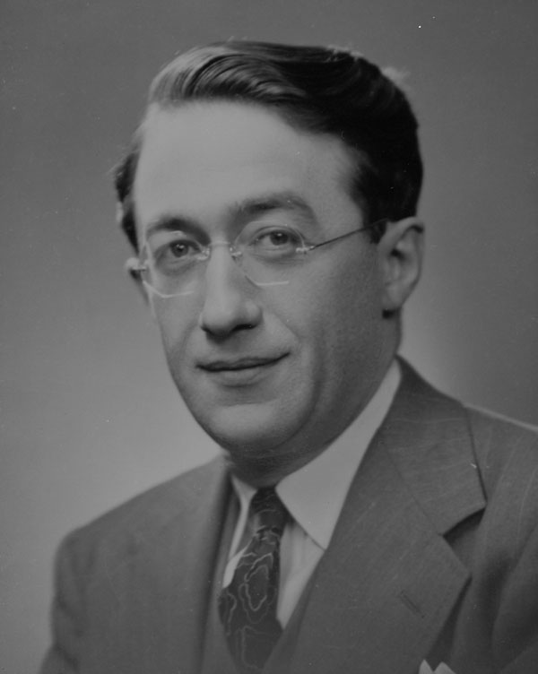  
A.M. Klein

Source: <http://www.collectionscanada.gc.ca/pam_archives/public_mikan/index.php?fuseaction=genitem.displayItem&lang=eng&rec_nbr=3217809&rec_nbr_list=3217809>

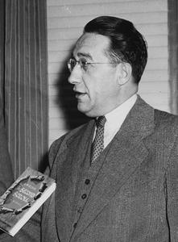  
A.M. Klein and *The Second Scroll*

Source: <http://www.cjhn.ca/permalink/211>

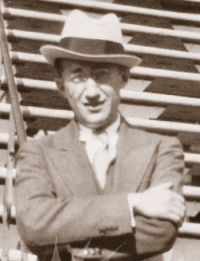

A.M. Klein

Source: <http://news.concordia.ca/faculties/011644.shtml>

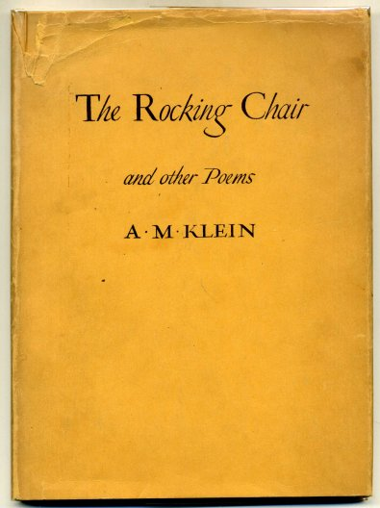

First Edition of *The Rocking Chair*<http://www.davidmasonbooks.com/oclists/elist33-32866.php>